# 

# **Department of Computer Science and Engineering Islamic University of Technology (IUT)** A subsidiary organ of OIC

# **Laboratory Report**

# CSE 4412 : Data Communication and Networking Lab

## 

## **Name: Chowdhury Ashfaq Student ID: 200042123 Section: A Semester: Summer Academic Year: 2021-22**

**Date of Submission: 6/3/23**

### **Title:** Configuration of RIP in a network topology.

### **Objective**:

1. Understand distance vector routing
2. Understand RIP
3. Understand the necessity of dynamic routing

### **Devices/ software Used**:

1. Cisco Packet Tracer
2. Router-PT
3. 296024TT switch

### **Theory:**

**Distance Vector (DV) Routing:**

DV routing is the process of finding the shortest path between routers through hop count which is determined from routing table.

**Count to Infinity problem in DV routing**

Each router has a routing table which has some fields like cost, via etc. Each hop adds 1 to the hop count and hop count can be maximum 16.

Now let’s assume router 2 is connected to router 3 directly with hop count 1. Router 1 is connected directly to router 2 with hop count 1. Router 2 and 3 is disconnected then for some reason but the routing table of router 1 says that it can send data to router 3 via router 2. Now, if we want to send data from router 1 to 3 then it won’t send rather it would enter into an inifinity loop which would end when the hop count becomes 16.

**Two node Loop problem in DV routing**

When count to infinity problem occurs between two routers then that is called two node loop problem.

**Split Horizon (one solution to instability)**

In split Horizon routing information won’t be broadcasted to the source.

**Poison Reverse ()**

In poison reverse max distance between routers would be broadcasted to the source. If two routers are disconnected then max distance is considered infinity.

**Routing Information Protocol (RIP)**

The process in which a router selects the shortest path to any network dynamically using the routing table is Routing Information protocol.

There are three versions of RIP.

**0**

### 

### **Diagram of the experiment:**

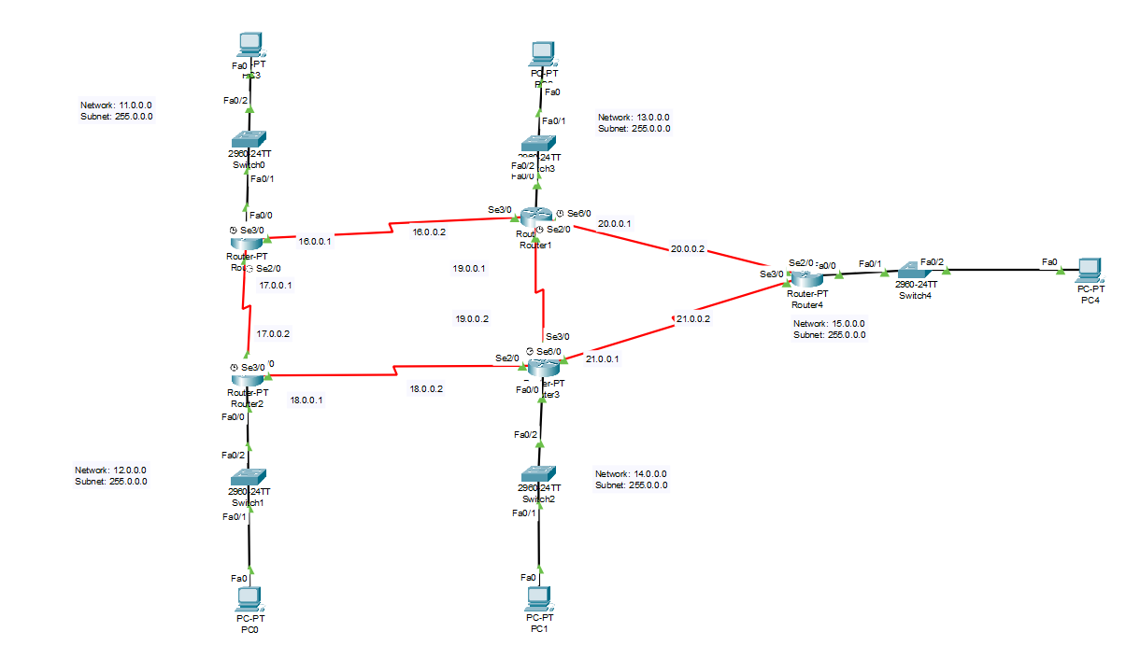

### **Configuration of Routers:**

Commands for configuring RIP

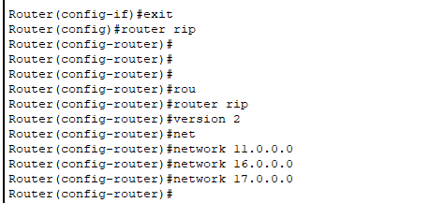

After entering the config-router we enter version 2 and then add all the networks adjacent to the router by the format ‘network network-address’.

### **Observation**:

***After setting up the RIP routing algorithm if Serial port Se3/0 of Router 4 is switched off then what are the changes occurred in Routing information of the routers.***

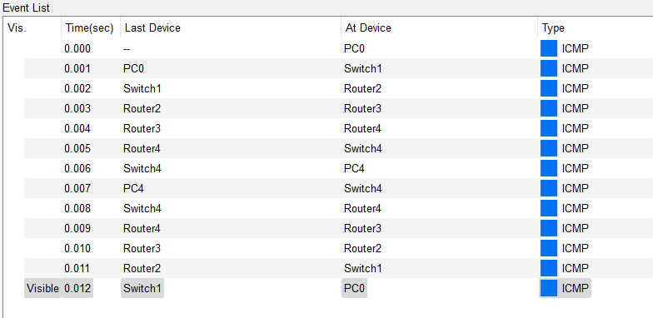

Fig: When Se3/0 port is turned on

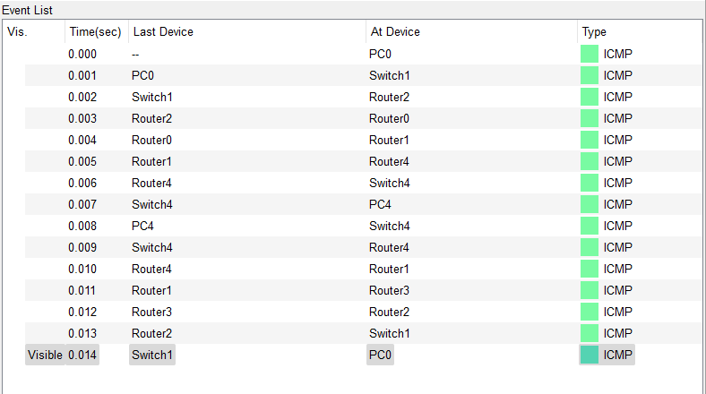

Fig: After Se3/0 port is turned off

When port is turned on then it follows a particular route of PC0-switch1-router2-router3-router4-switch4-PC4 and the total RTT is 0.012 seconds.

When port is turned off then it follows the route of PC0-Switch1-Router2-Router0-Router1-Router4-Switch4-PC4 and the total RTT is 0.014 seconds.

### **Challenges:**

* Using different RIP version caused problem.
* Understanding two node loop delay.

### 